

**Polling District and Polling Place Review 2025**

**Byker Ward**

**Parliamentary Constituency:** East and Wallsend

**(Proposed) Polling Districts:** D01, D02, D03, D04, D05

The Local Government Boundary Commission for England are an independent body accountable to Parliament. They are responsible for reviewing councils to make sure their patterns of internal wards are fair and sensible. Their reviews include at least two rounds of public consultation before they make recommendations for change.

The final recommendations were published on 7 January 2025, and the new arrangements apply to local elections from 2026.

As a result of changes to ward boundaries the Acting Returning Officer (ARO) is conducting a review of polling districts and polling places to ensure that they are suitable for the new ward boundaries.

For more information on the local government boundary review visit: <https://www.lgbce.org.uk/all-reviews/newcastle-upon-tyne>

This document provides details of the review, along with the initial recommendations and comments of the Acting Returning Officer (ARO). Also, the election rules require the ARO to decide how many polling stations are required for each polling station and the ARO must allocate electors to the polling stations in such manner as they think most convenient.

These recommendations will be open to all residents, stakeholders, and any interested parties. We shall be seeking representations from local disability groups on the accessibility and suitability of polling places. Any comments should be addressed in the first instance to pollingplaces@newcastle.gov.uk where they will be collated on behalf of the (Acting) Returning Officer.

We considered the following factors:

* **Identifying new polling places:** We will look for new polling places in areas where the existing provision is unsuitable or unavailable.
* **Feedback:** We will consider feedback received following recent elections, consultation from members of the public, elected members, and other stakeholders.
* **Accessibility:** We will try to ensure that every polling place is accessible to electors with disabilities.
* **Facilities**: We will make sure that all electors have such reasonable facilities for voting as are practicable in the circumstances.
* **Elector numbers:** We will try to comply with the Electoral Commission guidance on the maximum number of electors that should be allocated to a polling station which should not exceed 2,250.
* **Future housing developments**: We will consider the impact of proposed housing developments on polling station electorates.

THIS PAGE IS INTENTIONALLY BLANK

**(Current) Byker Ward**

This map shows the current ward and polling district boundaries and the polling places.

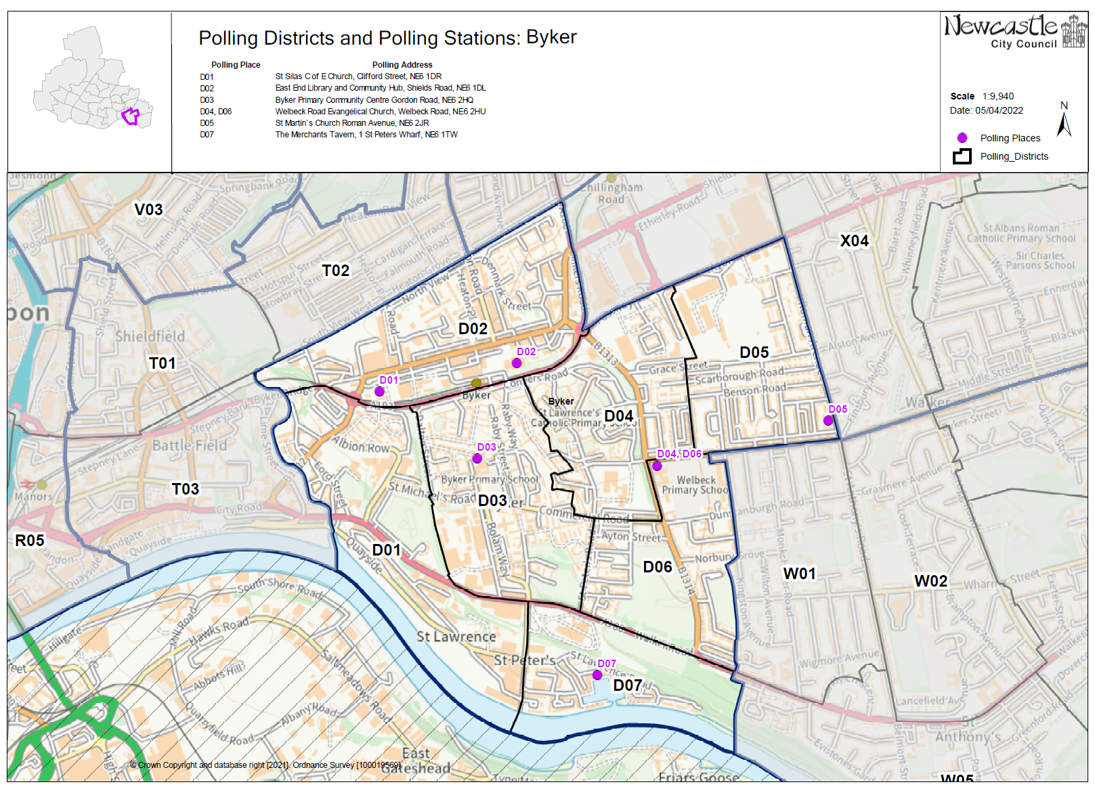

**(New) Byker Ward**

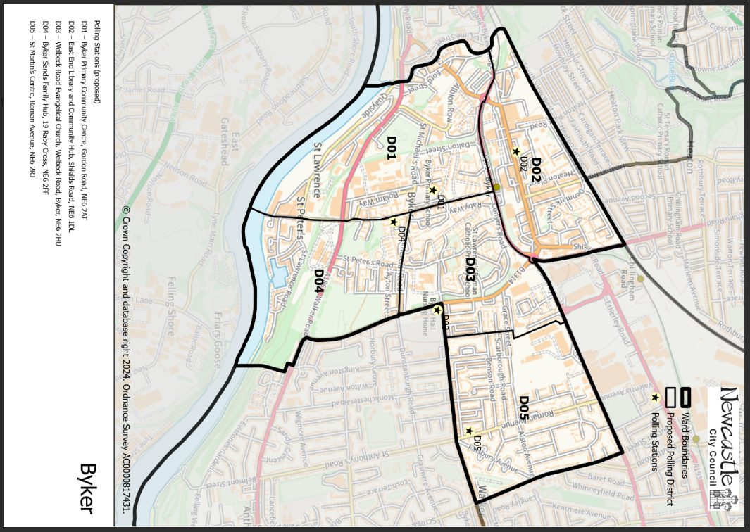This map shows the new ward and the proposed polling districts and the proposed polling places.

* D01 – Byker Primary Community Centre, Gordon Road, NE6 2AT
* D02 – East End Library and Community Hub, Shields Road, NE6 1DL
* D03 – Welbeck Road Evangelical Church, Welbeck Road, Byker, NE6 2HU
* D04 – Byker Sands Family Hub, 19 Raby Cross, NE6 2FF
* D05 – St Martin’s Centre, Roman Avenue, NE6 2RJ

**Byker Ward**

**Polling District D01**

|  |  |
| --- | --- |
| **Current Polling District** | **Current Polling Place** |
| D01 (full)  D03 (part of) | St Silas C of E Church, Clifford Street, NE6 1PG  Byker Primary Community Centre, Gordon Road, NE6 2AT |

|  |  |  |
| --- | --- | --- |
| **Proposed Polling District** | **Predicted**  **Polling Station Electorate** | **Proposed Polling Place** |
| D01 | 982 | Byker Primary Community Centre, Gordon Road, NE6 2AT |
|  |  |  |
| **Considerations and Proposals** | | |
| Merge current D01 and part of current D03 to create the proposed D01 district. The proposed D01 would expand out to the east to incorporate part of the current D03 district, including properties up to Raby Street.  Byker Primary Community Centre is the suggested polling station for the proposed D01 district, as St Silas is now located in the proposed D02 district. | | |
|  | | |
| **Preliminary Consultation – Elected Members comments and feedback** | | |
| No comments received. | | |

**Byker Ward**

**Polling District D02**

|  |  |
| --- | --- |
| **Current Polling District** | **Current Polling Place** |
| D02 (full) | East End Library & Community Hub, Shields Road, NE6 1DL |

|  |  |  |
| --- | --- | --- |
| **Proposed**  **Polling District** | **Predicted**  **Polling Station Electorate** | **Proposed**  **Polling Place** |
| D02 | 715 | East End Library & Community Hub, Shields Road, NE6 1DL |
|  | | |
| **Considerations and Proposals** | | |
| No change to the polling district boundary.    No change to the polling place. | | |
|  | | |
| **Preliminary Consultation – Elected Members comments and feedback** | | |
| No comments received. | | |

**Byker Ward**

**Polling District D03**

|  |  |
| --- | --- |
| **Current Polling District** | **Current Polling Place** |
| D03 (part of)  D04 (full) | Byker Primary Community Centre, Gordon Road, NE6 2AT  Welbeck Road Evangelical Church, Welbeck Road, Byker, NE6 2HU |

|  |  |  |
| --- | --- | --- |
| **Proposed**  **Polling District** | **Predicted**  **Polling Station Electorate** | **Proposed**  **Polling Place** |
| D03 | 1332 | Welbeck Road Evangelical Church, Welbeck Road, Byker, NE6 2HU |
|  | | |
| **Considerations and Proposals** | | |
| Merge current D04 with part of the current D03 to create the proposed D03 district. The western polling district boundary line now runs as far as Raby Street.  Welbeck Road Evangelical Church is located just outside of the new district, however, there are no other alternative stations in the area. | | |
|  | | |
| **Preliminary Consultation – Elected Members comments and feedback** | | |
| No comments received. | | |

**Byker Ward**

**Polling District D04**

|  |  |  |  |
| --- | --- | --- | --- |
| **Current Polling District** | **Current Polling Place** | | |
| D03 (part of)  D06 (part of)  D07 (full) | Byker Primary Community Centre, Gordon Road, NE6 2AT  Welbeck Road Evangelical Church, Welbeck Road, Byker, NE6 2HU  The Merchants Tavern, 1 St Peter’s Wharf, NE6 1TW | | |
|  | | | |
| **Proposed Polling District** | | **Predicted**  **Polling Station Electorate** | **Proposed Polling Place** |
| D04 | | 764 | Byker Sands Family Hub, 19 Raby Cross, NE6 2FF |
|  | | | |
| **Considerations and Proposals** | | | |
| Merge part of current D06, part of current D03 and D07 to create the proposed D04 district. The proposed D04 district includes properties up to Glasshouse Street in the west, Commercial Road in the north and Allendale Road in the east.  Byker Sands Family Hub is suggested for the proposed D04 district. Site visit took place on the 7 August 2025 and confirmed that the building meets accessibility requirements. | | | |
|  | | | |
| **Preliminary Consultation – Elected Members comments and feedback** | | | |
| No comments received. | | | |

**Byker Ward**

**Polling District D05**

|  |  |
| --- | --- |
| **Current Polling District** | **Current Polling Place** |
| D05 (full)  X04 (part of) | St Martin’s Centre, Roman Avenue, NE6 2RJ  93rd Scout Headquarters, Triella Hall, 18 Walpole Street, NE6 4RL |

|  |  |  |
| --- | --- | --- |
| **Proposed Polling District** | **Predicted**  **Polling Station Electorate** | **Proposed Polling Place** |
| D05 | 1583 | St Martin’s Centre, Roman Avenue, NE6 2RJ |
|  | | |
| **Considerations and Proposals** | | |
| Merge current D05 and part of current X04 to create the proposed D05 district. The proposed D05 takes on properties to the east of Roman Avenue, as far along as Scrogg Road, from Walkergate ward.  St Martin’s Centre will remain as the polling station for most electors. | | |
|  | | |
| **Preliminary Consultation – Elected Members comments and feedback** | | |
| No comments received. | | |